**Project Design Phase-II**

**Technology Stack (Architecture & Stack)**

|  |  |
| --- | --- |
| Date | 02 March 2025 |
| Team ID | PNT2025TMID02554 |
| Project Name | Global Malnutrition Trends: A Power BI Analysis (1983-2019) |
| Maximum Marks | 4 Marks |

**Technical Architecture:**

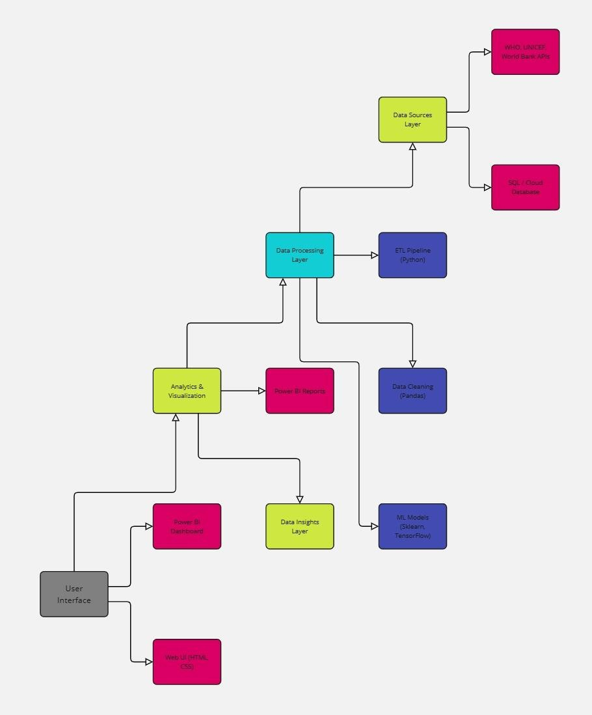

**Table-1 : Components & Technologies:**

|  |  |  |  |
| --- | --- | --- | --- |
| **S.No** | **Component** | **Description** | **Technology** |
| 1. | User Interface | Web based interactive dashboard for users | Power BI,HTML, CSS |
| 2. | Application Logic-1 | Data cleaning,Transformation,and aggregation | Python(Pandas) |
| 3. | Application Logic-2 | Data ingestion from various sources | ETL pipleline(SQL ,Python) |
| 4. | Application Logic-3 | Machine Learning For trend Prediction | Scikit-learn,Tensorflow. |
| 5. | Database | Storage of malnutrition | MySQL, Postgre SQL. |
| 6. | Cloud Database | Cloud Storage for scalability. | AWS,RDS,Google bigqurey. |
| 7. | File Storage | Storage for report and analysis files. | AWS,S3,Google Drive. |
| 8. | External API-1 | Data source API for global health data. | WHO,API,World Bank API. |
| 9. | External API-2 | Socioeconomic factors data integration. | IMF API,FAO API. |
| 10. | Machine Learning Model | Predictive analysis for malnutrition trends. | Regression Model,CNN. |
| 11. | Infrastructure (Server / Cloud) | Deployment platform for power bi. | Microsoft Azure,AWS, |

**Table-2: Application Characteristics:**

|  |  |  |  |
| --- | --- | --- | --- |
| **S.No** | **Characteristics** | **Description** | **Technology** |
| 1. | Open-Source Frameworks | Use of open-source libraries for data analysis and | Python ,Pandas,Matplotlib |
| **S.No** | **Characteristics** | **Description** | **Technology** |
|  |  | visualization . |  |
| 2. | Security Implementations | Data encryption ,access control,and Secure API integration. | SSL,OAuth,LAM controls. |
| 3. | Scalable Architecture | Cloud-based scalable powerBI dashboard | Microservice,AWS Lambda. |
| 4. | Availability | High availability through cloud redundancy and backups. | Load Balance,CDNs. |
| 5. | Performance | Optimized performance with caching and parallel processing | Redis,CloudFront,FastAPI. |